Project: Flu Infection
Difficulty: Level 3

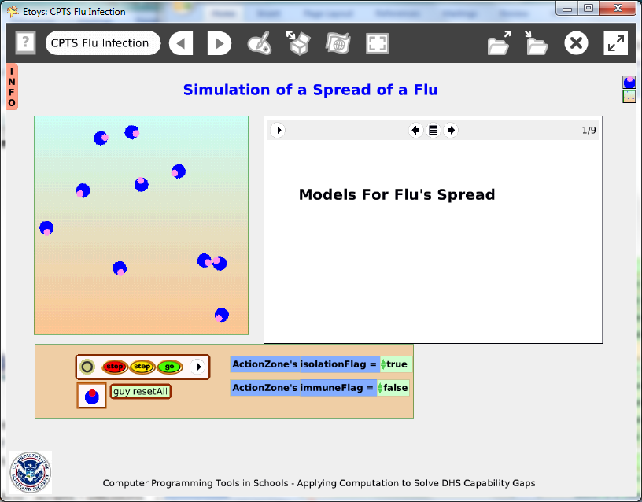

Time: Five 45 minute labs

Challenge:
Create a simulation of flu infections with variables including immune people in the population and the effect of quarantine on the rate of spread of the disease.

Programming:
This project includes creating variables and random numbers and using them in conditional statements. It uses a playfield’s watchers to provide controls to change conditions as the simulation runs.

Things you’ll need to know:
Quick Guides
- Paint Tools/ All
- Halo Handles/All
- Supplies: Text, All Scripts, Add a New Flap
- Script Tiles: Forward by, Bounce, Heading, Hide and Show, Random Numbers, Tests Category
- Menus: Normal Ticking, Scriptor Icon Set, Viewer Icon Set, Watchers
- Books: Top Border Icons, Expanded Controls, Working with Layers, Navigation Tiles

Things to think about:
This model has a limited number of variables and students should think about whether it is accurate enough to predict results based on data about a specific kind of flu. What other factors would be necessary to improve accuracy? Class discussions or student research about kinds of flu that are in the current news will give this project immediacy. Questions such as, should immunizations be required and should people with the flu be quarantined could be the basis of interesting class discussions.

Extensions:
Modify the model by adding probability variables to the events.
Research methods of disease control mechanisms and their application in local events. Discuss the effect of people choosing to decline the vaccines that prevent preventative or moderate the effect of numerous illnesses such as: polio, whooping cough, flu and tuberculosis.

http://www.ncbi.nlm.nih.gov/pubmedhealth/PMH0004522/ Bird flu Information from the National Institute of Health

http://www.ncbi.nlm.nih.gov/pubmedhealth/PMH0002528/ Whooping Cough

http://www.usatoday.com/news/world/story/2012-01-22/china-bird-flu/52740926/1

Current international news (January 2012) includes articles about polio in India.
http://www.polioeradication.org/Dataandmonitoring/Poliothisweek.aspx

http://www.unicef.org/infobycountry/india_61293.html
NETS for Students:
1. Creativity and Innovation: a, b, c, d
2. Communication and Collaboration: a, b
3. Research and Information Fluency: a, b, c, d
4. Critical Thinking, Problem Solving, and Decision Making: a, b, c, d
6. Technology Operations and Concepts: a, b, c

CSTA:
CSTA Level II: Objectives and Outline
http://csta.acm.org/Curriculum/sub/CurrFiles/L2-Objectives-and-Outlines.pdf
Level II objectives for middle school students are furthered through studying a programming language well enough that the student is proficient with it. Whether the language is Etoys, StarLogo TNG, or Scratch, it is the ability to use the language to express ideas that is valuable. A student skillful enough to use any programming language to express ideas, solve problems, model behaviors, simulate data, or to educate or entertain is an entitled person in today’s society. Topics of particular note are:
Topic 2: Problem Solving
Topic 6: Connections between Mathematics and Computer Science
Topic 11: Programming Languages
Topic 13: Multimedia

Common Core Standards Mathematics:
7. SP.7b
Mathematics/ High School – Modeling (pages 72-73)

Teacher Notes:
Materials:
This project lesson includes extensive teacher notes as well as a student handout with a series of questions that can be answered through the use of the finished project. The use of this project can be independent of whether the student made a similar Etoys project or used the exemplar project. Not all questions in the handout have precise answers but should be used to generate discussions about the limits of models.

Comments: Objects - Scripts – Decisions
The project has several objects to represent various stages of health and illness. The book is a useful tool for students who want to include more information about the illness they have chosen to represent. Making the book takes additional time devoted to research on the topic and to creating a multi-page document in book form. Students should read about current flu epidemics and incorporate facts about number of people vaccinated/number exposed.

Two other objects that take additional time to modify for use in the project are: T a flap with additional information and a small playfield where the action occurs.

Example Scripts:

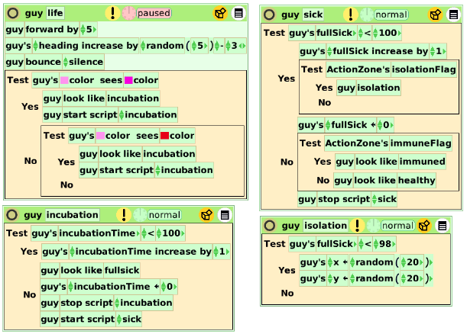
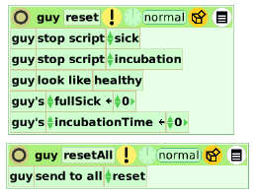

Flu Infection
This applet is intended to have students observe the spread of a flu virus. The first page of the student worksheet is just a set of definitions for the vocabulary used. Your students may or may not need this.

Below are some suggested answers your students may have:

1) Click “Go” and watch the healthy guys move around the playfield. What happens when they come in contact with each other?

Nothing happens

2) Click on the “sick” guy in our command station, drag him up to just touch one of the healthy guys in the playfield and then put him back in his spot in the command station and click to set him down. Now watch and describe what you see happening in the playfield.

(Answers can vary)

When he comes in contact with others they start to get sick.
After a time they are sent to the lower left corner.
They stay there until they get better and then they get out.
He never touched anyone so everybody is okay.
He got better so now no one is sick.
3) Click the “guy resetAll” button and start the simulation again. Watch and record. Do this three more times.

(Again, answers can vary)

The same thing happens
Probably they will conclude that every one eventually gets better
Some may notice that some of the guys get sick twice.

3) Ask others in the class if they see the same things happening on their screen. If not, how might you explain the difference?

There may be some differences, but generally everyone will end up well.

4) Is there an ultimate outcome you can count on to happen? If so, what is it?

See above

Now let’s play with the Isolation Flag. Set it to false, reset the simulation, click go, infect someone and observe. Run the simulation several times.

5) How does this differ from having an Isolation corner?

EX:
It takes longer for everyone to get well.
Some guys get sick more than once.
They just keep passing it around.
Everyone gets sick.

6) Does Isolation see to be a good idea?

General consensus should be YES
7) Let’s try a new kind of flu that you can only get once. This means we need to make the ImmuneFlag true. Leave the IsolationFlag as false. What do you think will happen now?

Guys will get sick only once

8) Reset the simulation and click go to infect someone and watch. What happens? Try this simulation three times.

It was a shorter time before everyone was okay.
Some never got sick.

9) Did everyone get sick? How do you know?

No, they aren’t green and stayed pink.

10) Turn Isolation to true. Now we have Isolation and Immune as true. What do you think might happen?

Fewer guys will get sick.
They will all be immune sooner.

11) Run this simulation three times and report on what you see.

More of them never got sick
It was all over sooner.

12) Is it better to have isolation, even if you become immune? Why or why not?

Consensus should be YES

Student Notes:
Infection Student Handout

The Infection Etoys applet will allow you to investigate how the spread of an infectious illness, like Flu, might look in a population. To begin we should cover some vocabulary;

Infectious illness: This is an illness that spreads by contact with germs. If one person has an illness they can spread it by coming in contact with another person. The contact might be by touching another person, coughing around another person, touching the food later consumed by another person, or leaving germs on objects that another person may later touch.

Incubation period: This is the length of time between when a person is infected (picks up the germ) and when they start feeling ill. A person can have the germs but not know it

Contagious: When a person has come in contact with the gems for an infectious illness they are then said to be contagious. This means that others may pick up the germ for the illness for some given period of time. A person can be contagious even if they do not appear to have the illness. In some infectious illnesses the contagious period is actually over before the person even feels ill. This means they are contagious during the incubation period. This makes it hard to tell who might be contagious. Some people, who pick up a germ and are therefore contagious, may never even actually get ill.

Immune: With some types of infectious illness, once a person has had the illness, the germs that cause the illness with no longer infect them. This means they will not get the same illness again, even if they come in contact with an infected person. Their body has built up “immunity” to the germ. In some cases a person just has immunity to the germ and will never get the illness. Each person’s body is different when it comes to germs.

Isolation (Quarantine): Isolation is a place where a person has limited contact with others. If it is know that a person has come in contact with an infectious germ, it is sometimes wise to put them in a place where they cannot spread the germ. We say the person is in “quarantine”. This is one way to try to stop the spread of an infectious illness.

Probability: As stated above, not everyone who comes in contact with an infectious gem will actually get ill. Every person’s body can reacts differently to germs. In many cases only a fraction of those who contact the germ will get ill. This fraction is called the probability and is usually described at a percent. 0% means no one gets infected, 100% means everyone gets infected. To stop an infectious illness completely you would need everyone to be immune.

So now let’s look at the applet. In upper left of the window you will see an “INFO” flap. Open this and read about the model and then close the flap. On the screen you will see a square “playfield” area with 10 circles or “guys” who are healthy (pink spots). Below that is a rectangle that holds your command station. You have one “sick” guy (red spot), an “Isolation” flag and an “Immune” flag. These can be set to true or false. To begin the model, Isolation should be true and Immune should be false. There is also a “guy resetAll” button to start the simulation over, and Stop, Step, and Go buttons to control the action.

You are now ready to play with the model.

Spreading the Flu Name_____________________________________

1) Click “Go” and watch the healthy guys move around the playfield. What happens when they come in contact with each other?

2) Click on the “sick” guy in our command station, drag him up to just touch one of the healthy guys in the playfield and then put him back in his spot in the command station and click to set him down. Now watch and describe what you see happening in the playfield.

3) Click the “guy resetAll” button and start the simulation again. Watch and record. Do this three for four times.

Trial #2

Trial #3

Trial #4

3) Ask others in the class if they see the same things happening on their screen. If not, how might you explain the difference?

4) Is there an ultimate outcome you can count on to happen? If so, what is it?

Now let’s play with the Isolation Flag. Set it to false, reset the simulation, click go, infect someone and observe. Run the simulation several times.

5) How does this differ from having an Isolation corner?

6) Does Isolation seem to be a good idea?

7) Let’s try a new kind of flu that you can only get once. This means we need to make the ImmuneFlag true. Leave the IsolationFlag as false. What do you think will happen now?

8) Reset the simulation and click go; infect someone and watch. What happens? Try this simulation three times.

9) Did everyone get sick? How do you know?

10) Turn Isolation to true. Now we have Isolation and Immune as true. What do you think might happen?

11) Run this simulation three times and report on what you see.

12) Is it better to have isolation, even if you become immune? Why or why not?

To play with this applet a bit more, you can go back to the start and instead of infecting only one person each time, try infecting three and see what happens. What do you think will happen?

